Angels Children’s Home

“As you have done it unto the least of these my brethren you have done it unto me” (Matthew 25:40)

Dear Sir/Madam,

The purpose of this letter is to kindly request your support and collaboration by way of making a financial contribution to a children's project under the title "Angels Children's Home project" to be undertaken in Addis Ababa Gullele Sub-City Kebele 01.

As you are well aware the problem of street children is one of the critical social problems in Ethiopia. The problem is particularly rampant in the city of Addis Ababa where an estimated 60,000 to 100.000 street children are believed to be in need of great support from all concerned bodies.

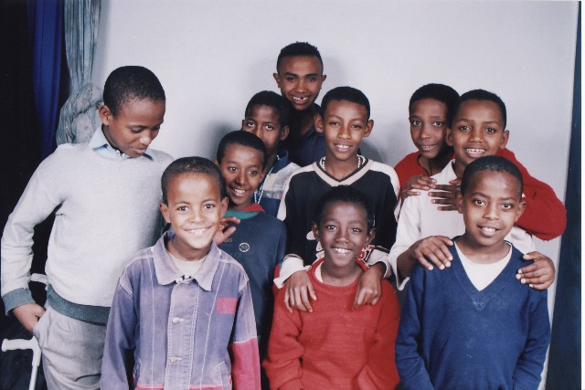

The primary objective of the Angel's Children’s Home Project is to provide care and support for 20-30 children by creating a nurturing environment in which the targeted children will live together as a united family. The project is designed to address the basic survival needs of the targeted street children which include food, shelter, clothing, and medical support together with psychological support and counseling with a view to make the children experience love, friendship discipline and sharing important life values. The center will also provide sound education and skill trainings in order to equip them with the necessary skills to sustain their living when they leave the center. The project is to be implemented under the umbrella of the Ethiopian Catholic Church in the parish of Kebena Kidane Mihret Catholic Church.

Since the past year some encouraging progresses have been made to realize the above mentioned objectives. The land where the center is to be built has been acquired and the building facilities will be erected. Most of the finance required (about 75%) to erect the building facilities have already been secured and therefore the construction activities will commence soon. Therefore the very purpose of this financial support request is to solicit the required project fund for the completion of the construction activities and to procure the necessary equipments and furniture and cover the running expenses of the center for the coming three years.

The above medical, social causes for children or anyone to be on the street and made so vulnerable are still not reason enough for many to help ... but underlying all is an EXISTENTIAL reason. We all come forth from the same SOURCE and are thus created having a necessary, one could say CONNECTION – relationship with every man, woman and child, my brother, my sister...my responsibility ....will you refuse?

The total estimated project fund required for the realization of the project is estimated at Birr 1,817,140(Euro 173,060.9)

I am therefore appealing to your generosity to contribute to the financing of this center in order to make this project a success. Attached herewith please find a Concept Paper of the project in order to give you a general aim and scope of the project activities. Also attached is the Construction Plan of the Angels Children’s' Home. On receiving your positive reply I can present the actual project proposal with all the detailed information and financial breakdown.

If you need further information or have any enquiries about the project please do not hesitate to contact me by email: ticcatic@yahoo.com or telephone: 251 0911 336872 or Abba Lisane Christos, Secretary General of the Archdiocese Catholic Secretariat: Telephone: 251 0116 626256 (Office); 251 0911 217704 (mobile) email: acsec@ehionet.et

Cheques can be made payable to ‘Angels Children’s Home’ and sent to Margaret Tonna-Barthet, 61, Flat 2, Triq Windsor, Sliema, SLM 09. The HSBC ‘Angels Children’s Home’ account number is 006 043 020 051

Waiting in anticipation to receive your positive reply I remain

faithfully Yours
Monica Tonna-Barthet
Administrator

