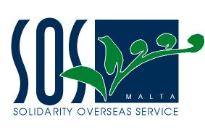

Dar L-Emigrant, Castille Palace Valletta VLT01 Malta Tel. +356 21240255 Fax +356 21240022
www.sosmalta.org info@sosmalta.org

SOS Malta’s Operations in Sri Lanka

The tsunami killed 35,322 people, displaced 1,000,000 persons and affected over two thirds of the island’s coastline and outlying 13 districts. Besides the tremendous loss of life and injuries, the tsunami caused extensive damage to property and disruptions of fisheries and other livelihood activities and business assets.

Thanks to the quick response by the government, local communities, local NGOs, private sector and the international community, the country recorded no additional deaths because of tsunami related diseases or lack of delayed medical treatment. SOS Malta was amongst the international community cooperating in order to ensure that humanitarian assistance reached those in need.

Since January 2005 SOS Malta went beyond the emergency level and has been working on the ground assisting in the recovery and reconstruction process.

Our main focus has been to work within the outlined projects presented to the Ministry of Foreign Affairs for funding namely:

- St Mary’s Convent School Improvement in Matara
- Livelihood Recovery Programme

However having acquired the expertise of Mr Marco Cremona on Water and Sanitation SOS Malta took a decision to implement Rain Water Harvesting Projects because most of the communities where we are working are unable to reach or cannot afford safe drinking water. SOS Malta acknowledges water as a human right and recognises the key role of water in agriculture, energy, health as well as in combating poverty. SOS Malta is committed to enhancing all efforts to satisfy basic human rights and help meet the Millenium Development Goals.

Livelihood Recovery Programme

The establishment of two fishing co-operatives amongst Matara Fort and Pollhena fishermen took place over a period of 4 months. The aims of the project were to provide a form of livelihood for the fishermen as part of the post tsunami rehabilitation process. Before actually talking about providing boats and engines, we spent the first couple of months getting to know the fishermen and collecting information on each one, we also worked in close contact with the FAO, exchanging information. The point of this lengthy process was to ensure that we did not repeat the same mistakes that other NGO’s had committed. We noted that other NGO’s had given equipment and boats to individuals who already owned the latter and as a consequence one year after tsunami, fishermen who had lost everything had still not received any form of aid. Another aspect of the co-operative was to make the fishermen pay a minimal monthly amount for the boat, engine and nets, this money would then go towards funding other projects and providing more aid. It also gave us some assurance that the fishermen were indeed using the boats. As previously reported SOS Malta is also engaged in helping to rebuild the tourist industry and over the past months has delivered equipment for the dive centres. Boats, engines and fishing nets.

The Co-operatives today:

We visited Sri Lanka and ‘our’ fishermen two months after our projects had been completed and noted that all had been catching large amounts of fish and were able to reconstruct their houses, provide for their families and pay off their monthly fees with the organization. One fisherman received damage to his boat and we have contacted the manufacturer to take care of the problem. In light of all this we feel that all the aims of the project have been successfully completed.

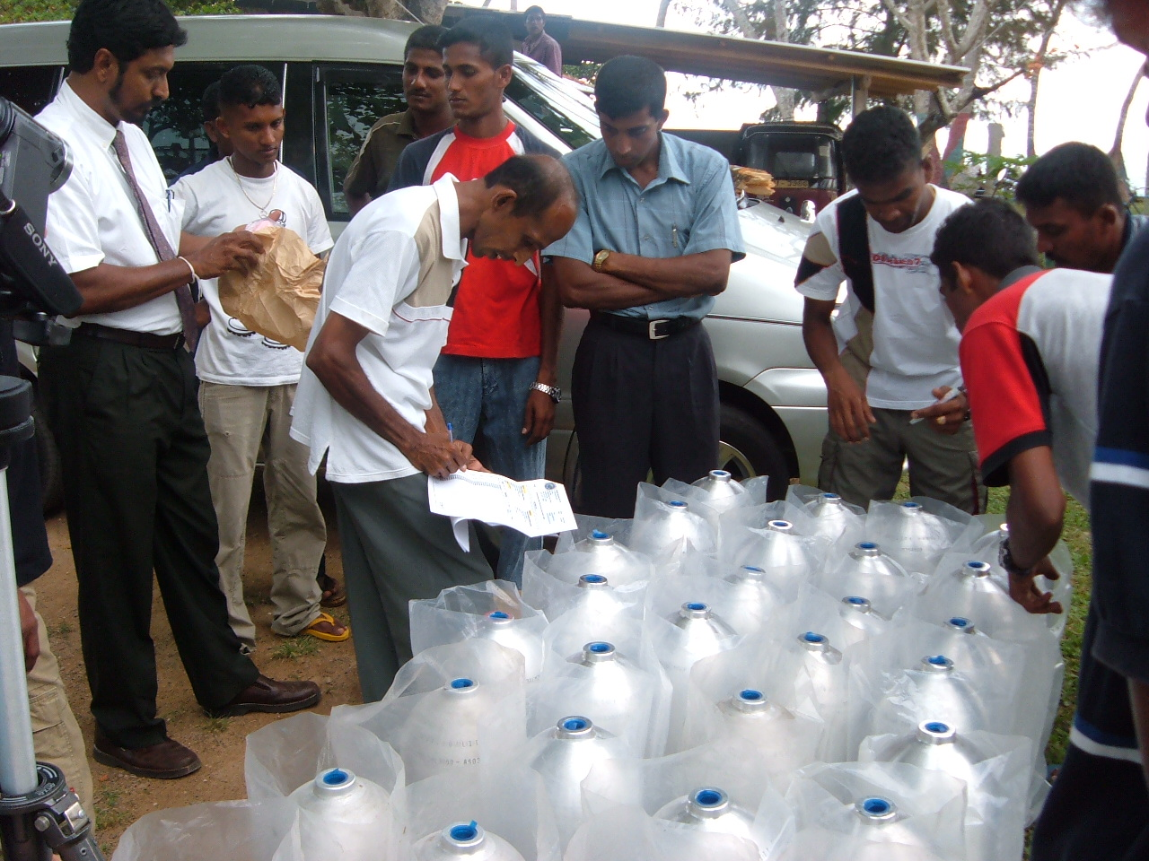
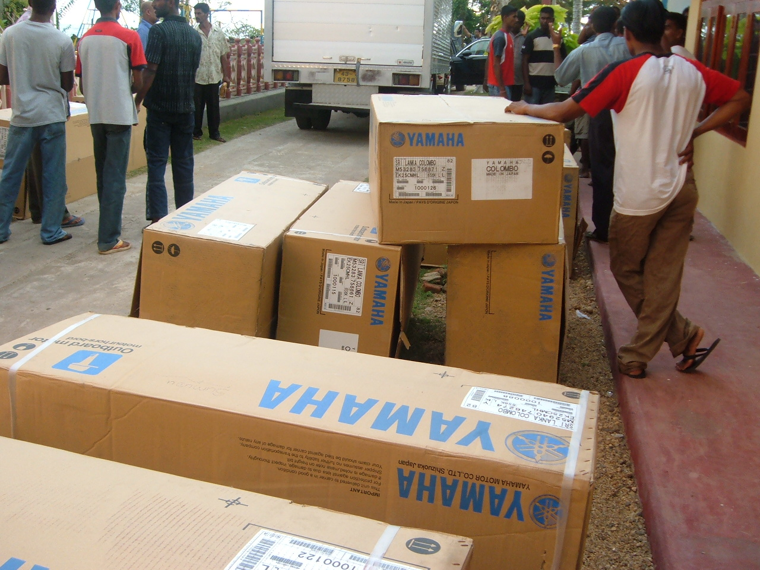
Cylinders for the Dive Centres Engines for Boats

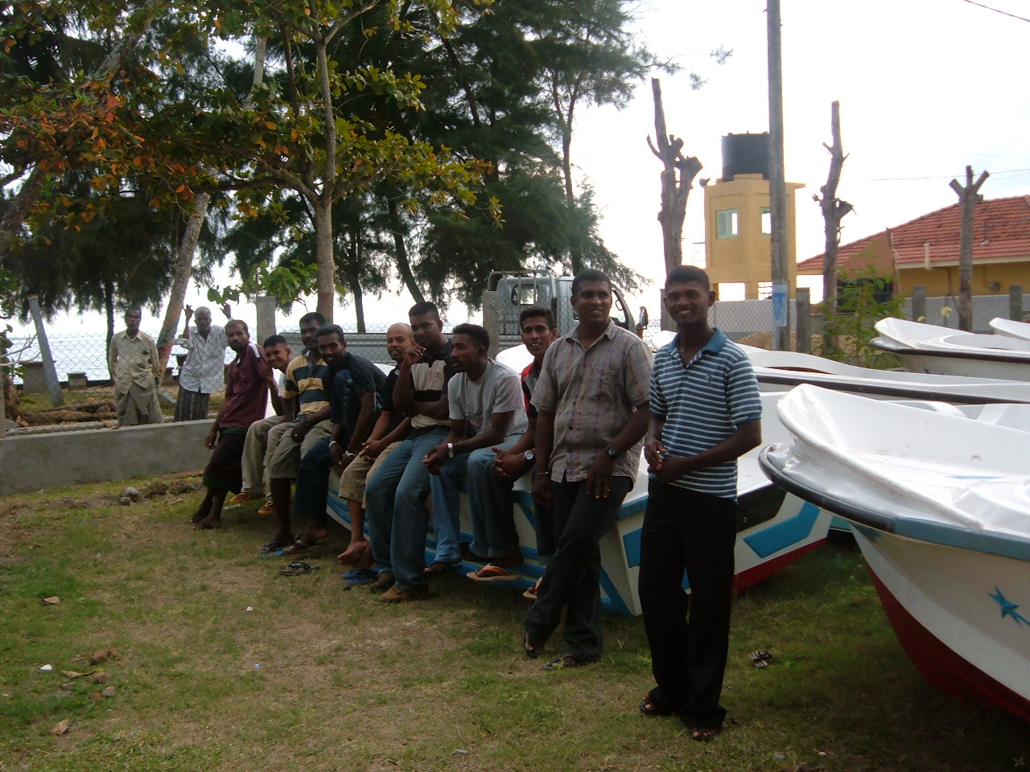

Pollhena Cooperative

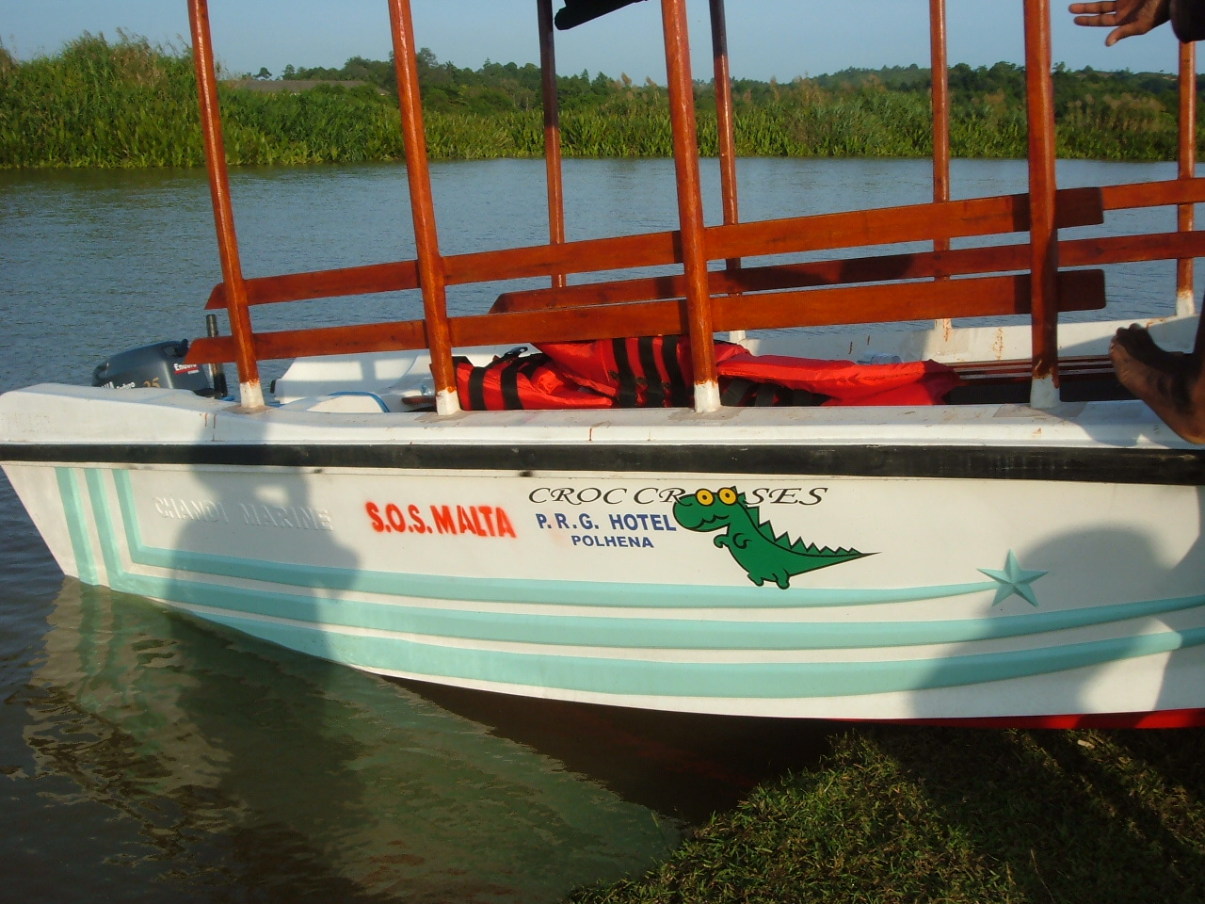
Boats used for ‘Croc Crooses’

St. Mary’s Convent School Improvement

To continue our commitment to the development planning at school and classroom levels SOS Malta made further contacts with the Society of the Sacred Heart in India and arranged for teachers to undergo a Master Training Course in Mumbai for a month. Ms Gloria De Souza from the Institute Parisar Asha was invited to join us to assess the teachers and design a course to fit in to the Sri Lankan curriculum. We are happy that the first four head teachers of St Mary’s Convent School have completed a month’s training in Mumbai and are now ready to pass on what they have learnt to other teachers through the Resource Centre set up by SOS Malta in Matara.

The COURSE-CONTENT for the month dedicated to ‘MASTER-TRAINING’, focussed on 5 crucial elements:

- From VISION to MISSION

- DEFINING our CHILD-CENTRED GOALS

- CURRICULUM PLANNING for a COMPREHENSIVE/INTEGRATED SCHOOL-EDUCATIONSYSTEM

- FOCUSSED IMPLEMENTATION

- PARTNERING/NETWORKING for SYNERGISED STRENGTH

The Director of Education in Matara has praised this initiative and is eager to extend the programme to other schools. SOS Malta will be looking at the possibility of offering the course again after receiving a full report from Mumbai.

The junior school reading room is now fully refurbished and equipped to include a Television, DVD and computer.

The success of SOS Malta’s programme of assistance to St Mary’s Convent is measured by the increase of commitment of all the sisters and teachers in meeting the vision and the set of goals decided upon together in March 2005. The school is now a better place for pupils to learn with all the improvements made as a distinct approach to educational change.

Junior School Reading Room

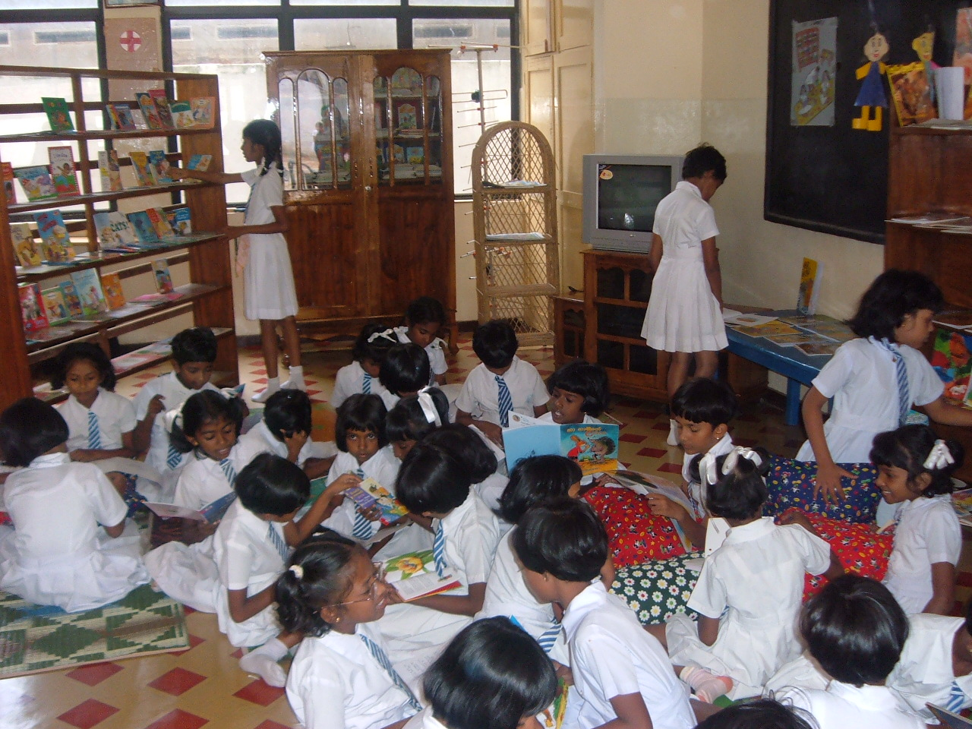

Reading Room

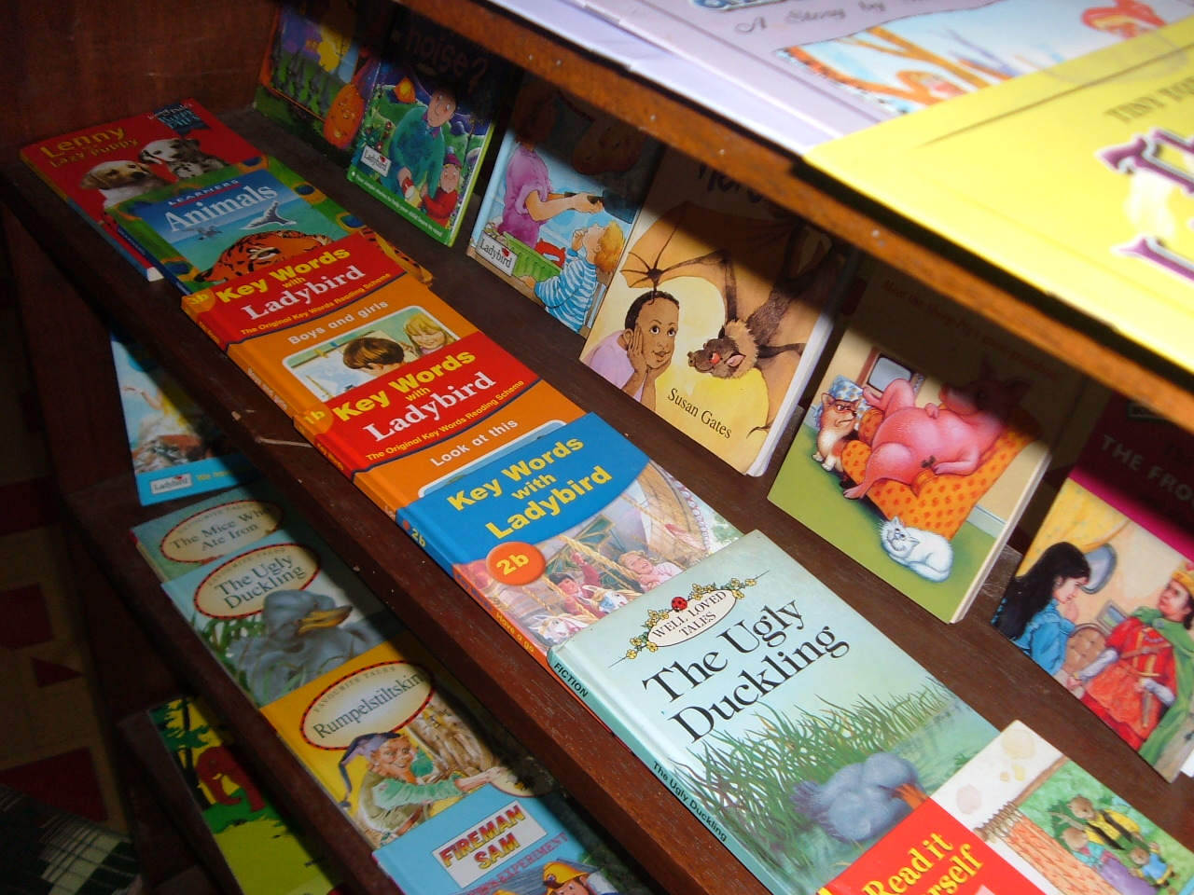

Over 500 Books were bought for the Library
Rain Water Harvesting Project in Welligama

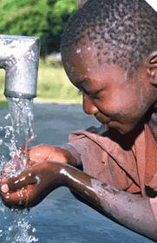

Project Objectives

To collect sufficient rainwater from:

The Orphanage building complex
The Christ the Healer Church building complex
A Sri Lankan home close to the orphanage

- offset most of the mains water costs of the orphanage
- offset most of the mains water costs of the church operations
- provide safe drinking water to the orphanage and the church complex to include the pilgrims who stop by the church throughout the year
- provide sufficient water to meet all the domestic water uses of the Sri Lanka home
- provide safe drinking water to 50 households in the vicinity of the orphanage

Channels around the buildings and underground water reservoirs have been constructed for orphanage, church and home. Pumps and UV filters installed for the system to provide complete self-sufficiency of the water needs as well as being a source of safe drinking.

SOS Malta will be extending the programme of Rain Water Harvesting to two other villages in the south of Sri Lanka in partnership with Caritas and SHARE Foundation of India.

Claudia Taylor-East
August 2006

