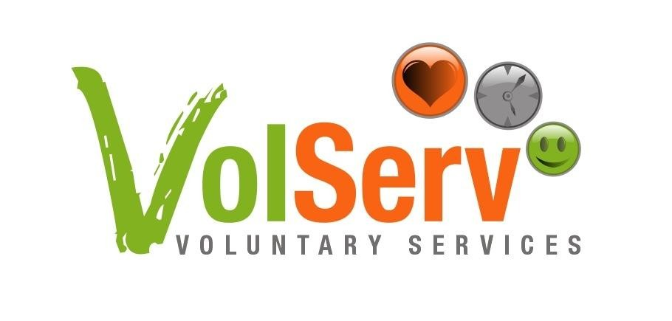
Interactive session with Mater Dei Hospital Staff and Dr. McKenna from Volunteer Centres Ireland

- Friday 31st October at 12.30 pm, the staff at Mater Dei Hospital (MDH) that currently have volunteers in their department and also those who are about to introduce volunteers into their departments, attended an interactive lecture at MDH by Dr. Yvonne McKenna.
- The lecture was entitled ‘Making the most of Volunteer Resources in a Hospital Setting’
- Dr. McKenna is the Chief Executive Officer of Volunteer Centres Ireland and was invited by VolServ, which is a project of the NGO SOS Malta in partnership with the Ministry of Social Policy. Ms. Nicola Critien from VolServ met Dr. McKenna at a General Assembly of the European Centre for Volunteering (CEV) last April in Ljubljana.
- Dr. McKenna spoke about the added value that volunteers give to an organization and that this was also true in a hospital setting. She highlighted that in order to make the most of these valuable resources all aspects of the Volunteer Management Cycle including Planning; Recruitment and Selection; Training and Orientation; Supervision and Evaluation, and Motivation and Recognition are the key to success of any volunteer programme. She also stressed that managing volunteers is both similar to and different from management of paid staff. Volunteer management involves applying some of the basic principles of people or paid staff management to the volunteers in the organisation. Essentially however, volunteer management is about respecting volunteers.
- Dr McKenna acknowledged that “Developing a system or structure of management for your volunteers means knowing why you want to involve volunteers, knowing what roles you want volunteers to do within your organisation and being prepared to involve them from before they enter the door, to the point of their departure. And after.”
- The first group of volunteers recruited and trained by VolServ, started their service in St. Luke’s Hospital in July 2007 and assisted in the migration to MDH. Currently, volunteers may be found in all the Outpatient clinics of the hospital. In the reception areas, volunteers offer a greeting and guiding service to patients and relatives visiting the hospital. Volunteers have also started keeping company to patients in the wards and organizing entertainment in the children’s wards. All volunteers are managed on site by the Voluntary Services Officer of MDH, Mr. Richard Cassar.
- The interactive session continued with a discussion with the staff members and all involved. Finally, Dr McKenna was thanked by VolServ Project Manager, Ms. Nicola Critien, who highlighted the benefits of communicating with staff on a regular basis in order to continuously evaluate the roles and input of the volunteers in the organization. The CEO of MDH, Ms. Marion Rizzo also expressed her thanks and commented on the fact that since the introduction of volunteers over one year ago, much progress has been made linked to the enhancement of the hospital’s services by volunteers, with more developments being planned for the future.

