Saturday, 13th June 2009

When the source of life dries up
Darrin Zammit Lupi
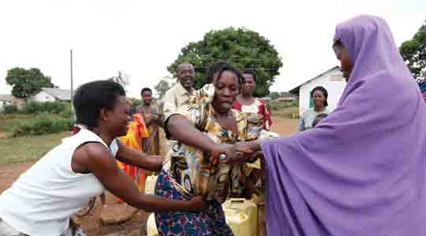
Photo: Darrin Zammit Lupi.
A widow has been queuing to fill her three jerrycans with water in the village of Namungalwe in eastern Uganda for two days. She's tired and frustrated.
Her children are home alone waiting for her to return. Suddenly, her patience runs out, she roughly bulldozes her way to the front of the queue, knocking over other people's water containers, and shoves her jerrycan under the water spout. People shout, hair is pulled, and the precious contents gush from the fallen cans into the mud.
She clutches the hand-operated pump and refuses to budge as two other women try to drag her away.
It's a common occurrence. The single water pump from a borehole is the only source of clean water for over 2,000 people in the area, about half of whom live in the village. Queues are always long. Hours spent queuing feel even longer.
Similar scenes are repeated all over the country. Water boreholes, and to a lesser extent springs, are the main source of water throughout most rural areas of Uganda.
The Times was recently in Uganda on a field trip, part of an EU-funded project entitled Media Engagement in Development Issues and Promotion.
The project, led by SOS Malta, aims at promoting awareness among policymakers and the public, through the media, in six of the new EU member states about development issues and the eight Millennium Development Goals.
When boreholes dry out or stop working in Uganda, the community finds itself in deep trouble. There is a mammoth problem of water shortages in the country. Rain water harvesting has not really been exploited on a large, effective scale, especially in water stressed areas.
One major problem with springs is they do not always provide a source of clean water. Springs are not protected - they are often contaminated by people and cattle bathing, and then that same water is collected to drink and cook with.
More water points are an urgent necessity for communities throughout rural Uganda. Because of the distances to reach the waterholes, young girls, often the ones responsible for collecting water, end up missing school, or worse, attacked and defiled on the miles-long lonely walks.
It is not enough for foreign NGOs to come into the country and drill boreholes, or build reservoirs. At the Katoosa primary school in Kyenjonjo in western Uganda, a reservoir with a capacity for 80,000 litres of water is bone dry.
There are no gutters on the roof to harvest water and feed it into the reservoir. Built in 2002 by the German federally owned Deutsche Gesellschaft für Technische Zusammenarbeit (GTZ), it was then left with no maintenance, nor was any instruction given to the community as to how to maintain it. Nor were any funds for maintenance available.
Consequently, a mere seven years later, it doesn't hold a single drop of water, while the community continues to suffer from chronic water shortage. Catherine Amal, the chief administrative officer of the Kyenjonjo district, laments that foreign aid has too many conditions attached and the time has come to relax those restrictions.
"You've taught me how to fish, but you haven't given me a fishing rod," she complained.
"We would like more infrastructure development because when you look around the area is full of poor people and poverty can only be removed by improving infrastructure services such as roads, water, electricity, better hospitals and schools. Most of the aid given to us through donors and NGOs is for training.
"What is needed is money to address the gaps in our infrastructure. The government and donors should change from giving us money for training, to money for infrastructure development. The people have been empowered, they know what they can do; they just lack the money to do it."
In fairness, this has already started happening. Development consultant Christina Roberts explained that originally, all aid was directed towards infrastructure and nothing was left for training or maintenance.
"However, because things would need to be rebuilt from scratch after falling into disrepair, donors went to the other extreme and only funded training and skills development and didn't give them anything to play with. But now they're beginning to find a balance," he said.
Meanwhile, people are forced to improvise. In a small hamlet outside Masaka in southern Uganda, a young widow in a small brick hut she shares with her four children and mother-in-law, uses a single strip of corrugated iron perched on a stick tilting into a battered jerrycan as a rudimentary form of water harvesting.
Without water, there can be no life, and it appears clear the lack of clean safe water is one of the root problems in the country. From it stem the problems of poverty, lack of sanitation, disease coupled with poor health care and infant mortality.
The UN's seventh Millennium Development Goal, ensuring environmental sustainability, speaks of halving the proportion of the world's population without sustainable access to safe drinking water and basic sanitation by 2015. The latest progress report indicates Uganda will probably achieve that goal.
According to the UNDP's Human Development Report 2007/2008, the number of Ugandans accessing improved water sources shot from 44 per cent in 1990 to 60 per cent in 2004, but there are fears the trend may be reversed if urgent measures are not taken to address the challenges of population growth, increased urbanisation and industrialisation.
Uncontrolled environmental degradation and pollution also threaten the quality and sustainability of the country's fresh water resources.
The Times will carry a series of reports from Uganda over the coming weeks.

