

info@mrc.org.mt | www.mrc.org.mt | Tel: 21244123 | Fax: 21224742 | Address: 9, Camilleri Court in Testaferrata Street Ta’Xbiex

Administrative back up to the NGO Networks and the National NGO Federation
The main aim of the Malta Resource Centre for Civil Society Non Governmental Organisations is to provide capacity building as a means to help NGOs and groups working for social change, development, health, environment, culture and the fight against poverty and social exclusion become more effective and efficient and better equipped to operate and participate within the European Union, specifically to influence policies and plans and access EU funds. Our vision is to provide stronger identity for the NGO sector and to develop structured systems of NGOs representation
This is done through the setting up of networks, providing a forum for sharing good and useful practices, provision of training and consultation, research, projects development, providing technical assistance for applying and managing EU funding and the promotion and development of corporate social responsibility (CSR).
MRC is a non-profit, non governmental organisation. It is independent of Government and any political party or organization.
One of the key means which MRC provides to support NGO networks and the NGO Federation is administrative back up. The role of MRC is to facilitate the process and the day to day administration. This means that the NGOs which are member organisations of the networks/ federation can focus on the content and core work especially to influence policies and plans. (National Action Plans, structural funds, EU Directives etc)
To date MRC provides administrative backup to:

- EAPN Malta

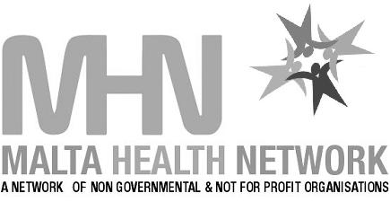
- The Malta Health Network

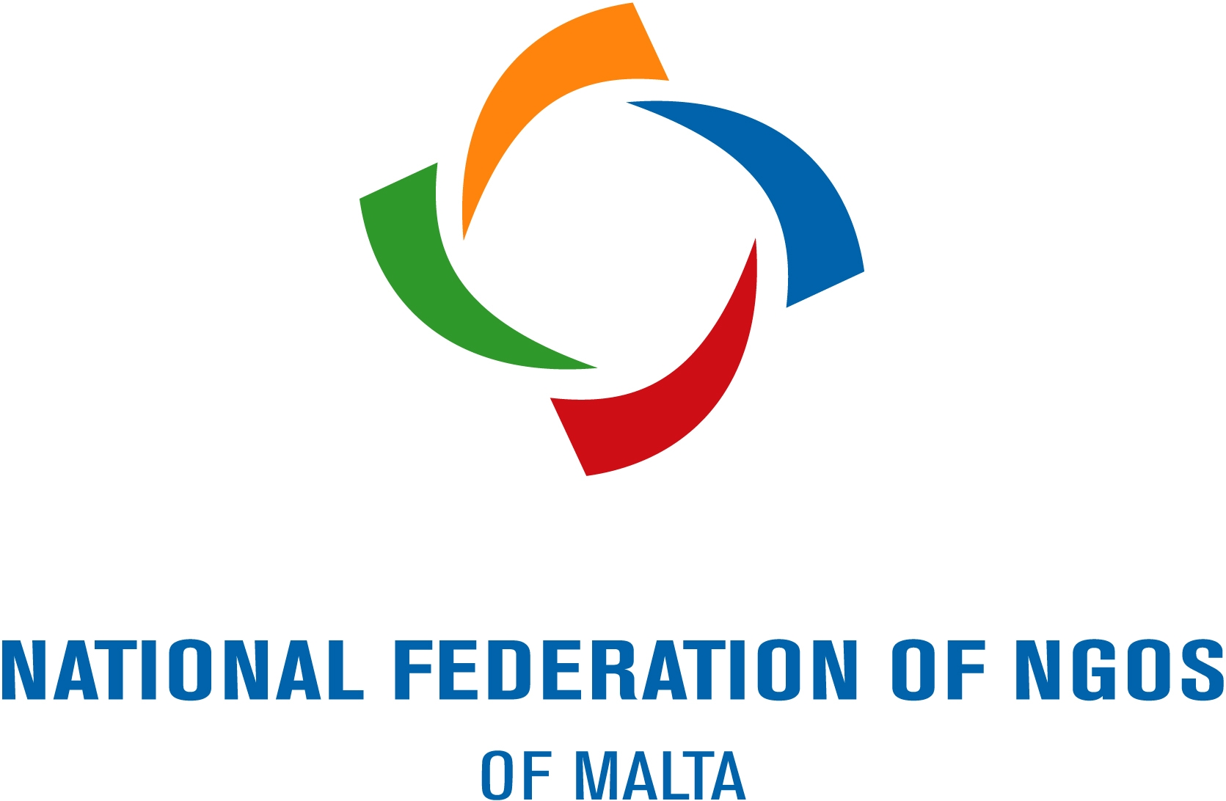
- The National Federation of NGOs of Malta

The Administrative Backup includes:
- Coordination and organisation of meetings (coordination / Executive committees, working groups, etc)
- recording of minutes/ notes of meetings
- record of all correspondence received and sent
- forward notices of meetings and circulate agendas (as set by the chairpersons/ presidents)
- communication with the member organisations
- keep and maintain a detailed record of each member organisation of the networks/federation
- Liaise with the Treasurer to ensure that such a list defines most clearly and at all times bona-fide members of the Federation. (especially when membership fees are applicable)
- information and updates for the member organisations
  - administer and use of the MRC website or websites of the networks/ federation
  - use of the MRC / networks/ federation e-newsletters
  - use of the MRC on-line NGOs database (to be launched by mid 2007)
- Communication and liaison with European and international affiliations related to the networks/Federation
- Communicate with the media (send out press releases written by the coordination/executive committees of the networks/federation, organise features, organise press conferences)
- Communicate and liaise with the government and relevant ministries
- Communicate and liaise with relevant stakeholders locally and abroad.
- Keep a record of each activity, especially as regards the date, place and nature of the activity as well as the attendance recorded.
- organisation of events, general assemblies and meetings related to the Networks/ Federation
- keep an up-to-date inventory of all publications that might be issued by the networks / Federation; and keep a record of all other publications (if any) owned by or in the possession of the networks / Federation
- writing of annual reports
- Obtain and manage funding and sponsorships to provide the above services

Last updated March 07

