Monday, 15th June 2009

Rejected girls and their unwanted babies
Darrin Zammit Lupi
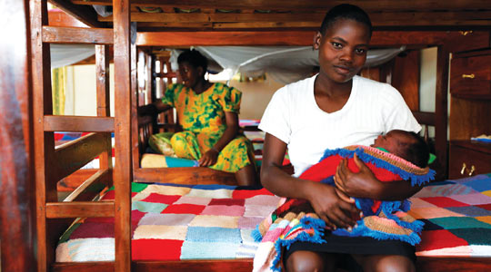
These are the wanted babies - Ugandan girls at a shelter for those who decide not to have an abortion. Photo: Darrin Zammit Lupi.
Eleven-year-old Jacinta Kayemba (not her real name) was walking back home through fields in Uganda with some friends, carefully balancing a bright yellow jerry can of water on her head which she had just filled at the village water borehole.
Suddenly, seemingly out of nowhere, a totally inebriated man jumped out of the bushes, terrifying the girls who broke into a frantic run away from the area.
Jacinta ran as fast as she could, all the while trying not to drop her can of water. She looked back to see if the man was chasing them and tripped. She crashed to the ground, looked up from the dust, and saw with horror that her precious cargo was pouring out of the jerry can as the cap had come off with the fall.
It was a slight relief to see that the drunkard didn't seem to be following her. But she was now gripped by a greater fear - returning home without water would surely incur the wrath of her parents. Her friends had disappeared from sight.
After some moments of hesitation, Jacinta decided to return to the borehole and refill the jerry can. Keeping her eyes peeled for any sign of movement in the bushes, she cautiously made her way back, placed her can under the spout, grabbed the large handle and started operating the pump handle, soon getting distracted by the rhythmic movement. She never saw the drunken man approach her from behind till he was pushing her to the ground, ripping her clothes and violently raping her.
Jacinta was too young to have ever had her period, yet it wasn't long before she and her family realised she'd become pregnant. Despite the circumstances of the pregnancy, her parents disowned her and threw her out into the streets. It made no difference that she was pregnant through no fault of her own - she had dishonoured the family. In a sense, she was lucky. Many girls in similar predicaments over the years have been thrown off high cliffs by their parents.
Many girls have no-one to turn to, nowhere to go. Some lucky ones may have relatives who may take them in but with abortion being illegal unless the pregnancy endangers a woman's life, many resort to back street abortions, often with devastating results.
Unsafe abortion, often from untrained personnel using unsafe methods, is a leading cause of maternal morbidity and mortality in the country. There are reports of poor women in villages resorting to desperate measures ranging from poisonous remedies from traditional healers to drinking detergents or inserting sharp sticks into their vaginas.
A 1993 study in Kampala hospitals found that 21 per cent of maternal deaths were due to abortion-related complications, the second leading cause of death. A 1988 survey among women aged 15-24 years found that 23 per cent of all the women that had ever been pregnant had had one or more abortions. There appears to be little indication that things have changed much - a 2005 study by the Guttmacher Institute in New York and doctors at Kampala's Makerere University found that a staggering 85,000 Ugandan women are treated for abortion-related health complications each year.
The Wakisa Ministries institute was set up by Vivian Kityo Wakisa to combat this trend. Funded by friends in the US and Australia, as well as some benefactors in Uganda itself, it receives no funding from NGOs. Primarily a crisis pregnancy counselling centre, it also serves as a temporary shelter for pregnant girls who have decided to go ahead with their pregnancy and have been rejected by their parents. It provides vocational training and the girls take care of household chores such as cooking, cleaning and gardening.
As I walked in, several pregnant teenage girls sat under a canopy in the spacious front garden, weaving baskets and knitting colourful blankets, all part of the handcrafts they do in order to raise funds for the ministry.
In the dormitory, a young mother, 17-year-old Sylvia, sat on her bed cradling her newborn child, aptly named Faith. Soon she would have to leave the institute and go and stay at an aunt's place as both her parents are dead.
Sylvia wants to go back to school, so her aunt will look after Faith, a beautiful child born out of a mistake made one fateful night. She may do as many like her have done before her, return to Wakisa Ministries to help run the centre and provide support to others who find themselves in a similar predicament.

