Tuesday, 16th June 2009

A town called dirt
Darrin Zammit Lupi
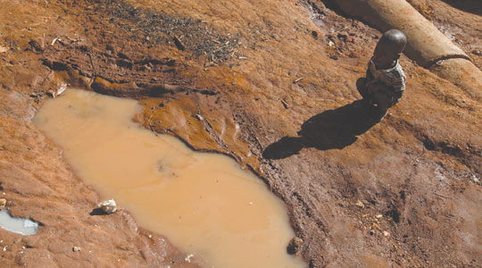
A child cries next to a puddle of muddy water in the slum of Kachuf in the Masaka district of south western Uganda. The word Kachuf in Luganda means dirt. Photo: Darrin Zammit Lupi.
The buzzing of flies, the whining drone of crying children, a cacophonic humdrum of sound of people going about their lives, numbs the mind.
A child, no more than two years old, squats alone in the mud next to a puddle of stagnant murky water, crying for his mother who is nowhere to be seen.
The overriding stench of urine mingling with frying of fish and other cooking are nauseating. Open sewers crisscross the village, their filthy effluent trickling through. Smoke from cooking fires lazily wafts through the air, catching the sunlight, creating a sense of drama where there is none.
Heavily laden clothes lines traverse the streets, forming a kaleidoscope of colours, unintentionally giving the place a surreal festive air. Cows, pigs and hens mingle freely with people, as though out for an evening stroll.
I'm in the sub county of Nyendo Senyange, in the Masaka district of south western Uganda, in a slum known to the locals as Kachuf. Kachuf is also a word in Luganda, the Ugandan language - it means dirt.
People coyly peer out of their homes from behind curtains, most very quick to vanish back into the shadows the moment they see a camera.
Among the mud brick houses are some that have been painted in a variety of bright colours, others have their façades tiled. Many are housed by prostitutes, women forced by dire circumstances to sell their bodies. Consequently, most are now HIV positive.
Some see the arrival of Europeans as an opportunity to get new clients. Two simply but strikingly dressed women follow me as I wander through narrow alleys, catching up with me and asking me to take their picture.
Another strikes a dignified pose in her doorway as I lift my camera while her naked baby walks gingerly on a fly-infested piece of sackcloth. Yet another invites me into her tiny shack, on the façade of which hang skewers of dried fish.
Outside her house are more racks with skewered fish from the nearby Lake Victoria and Lake Nabugabo. Meals meant for humans, but the flies have got there first.
On the main street of the village, a man stands besides a small wooden stall, meat hanging from rusty hooks. Parts of the meat appear black, moving and alive; it is the hundreds of flies crawling over it.
A drunken man, soaked in sweat, roams through the village trying to attract attention with unintelligible ravings. He's clutching a dirty beer mug, drinking potent alcohol derived from fermented pineapples. The heat is intense, yet he wears a thick cardigan.
It's overwhelming but intoxicating.
Vincent Ssempijja, Masaka District chairman, seems out of place as he walks around the slum. A tall imposing man in a smart suit, he is passionate about wanting to improve the living conditions of the inhabitants.
"We have problems of children who are malnourished, who don't go to school," he laments.
The parents cannot afford to send them to school, to buy books, even though there is universal primary education in Uganda.
In addition, most people in the densely populated slum live in makeshift homes with no sanitation. The lack of latrines and safe water is acute.
"We have managed to extend piped water to the area. People take water home in a jerry can. A 20-litre jerry can may have to serve 10 people in a single home for a day, so that's a severe lack of water, but that's all they can afford; water is sold, not given free," Mr Ssempijja explains.
In the hills outside the town, in a small nameless hamlet, a young widow, whose husband was killed in the civil war, lives in a small, simple two-roomed brick building in a field of mud with her four children and her elderly mother-in-law.
The inside is sparsely furnished with dusty straw mats on the mud floor and a couple of wooden stools. The children are barefoot, runny-nosed and dressed in mud covered clothes. A small black piglet is tied to a stake outside.
They survive on the little income they get from the surplus of the tiny banana plantation they have round the house, using the money for medicine when the children go down with malaria.
If they have no surplus, they remain without money to buy anything. Their situation is dire.
They cannot afford to pay for transport, usually provided by the boda-boda motorbike taxis, to go to a hospital, even if their lives depend on it.
Yet, the resilience of the people is impressive. Could it be their lives are not so miserable after all? The children might be walking barefoot, yet they're still smiling.
This is the third in a series of reports from Uganda raising awareness about the UN Millennium Development Goals with the cooperation of SOS Malta.

