Thursday, 25th June 2009

Beads of hope
Darrin Zammit Lupi
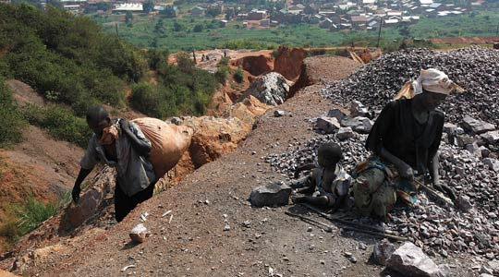
Women in colourful headscarves are out in the scorching sun on the rim of the quarry, sitting among mounds of granite rubble, lost in the rhythmic motion of hammering. Their young babies are next to them, oblivious to the danger posed by flying shards of granite as the women smash the rubble stones into smaller pieces using crude mallets.
Condemned by fate and circumstances to a life of hard labour, these are the Acholi tribe people who have fled their homes over the last 20 years because of the civil war raging in the north of the country.
For close to two decades, the cult-like Lord's Resistance Army (LRA) in northern Uganda has carried out civilian massacres and mutilations on a horrifying scale. Its enigmatic leader Joseph Kony wants to run the country on the lines of the biblical Ten Commandments, yet his methods could hardly be more evil.
The UN estimates that over 20,000 children have been abducted by the LRA to serve as child soldiers or sex slaves. More than 1.6 million people have been displaced and tens of thousands of civilians have been killed.
To date, a comprehensive peace agreement remains elusive.
The internally displaced people's camp, the Acholi tribe quarters in Mbuya, on a hill on the outskirts of the Ugandan capital, Kampala, is dominated by two granite quarries on either side. The land belongs to the king of Buganda, one of the traditional but politically impotent kings in Uganda, and is now home to over 5,000 people who were forced to flee their villages in the north.
The densely populated slum, much like any other slum around the country, is a haven for diseases such as malaria, dysentery, tuberculosis, HIV, scabies. Sanitation is poor, drainage facilities are virtually non-existent.
The quarries are huge gashes in the side of the hill - what were hills 10 years ago are now deep gorges, providing what for several years was the only way of earning some sort of livelihood for the people in the camp. On a good day, a woman might fill 20 jerry cans with the small stones, for which she'll be paid 2,000 shillings, equivalent to about 60c, barely enough to feed herself and her family.
Haggard looking men, their features worn by long hours in the sun and the sheer hardship of working in the quarry, carry sacks of rocks from the bottom of the gorge. Others perch perilously on the side of the steep slope, yielding sledgehammers to smash the rocks off the cliff face into smaller manageable pieces.
The heat from burning tyres is used to crack large rocks, making the quarrying process moderately easier.
It's the sort of place where there's no such thing as health and safety. The job is extremely dangerous. Accidents, ranging from a smashed hand or finger because of a mis-aimed mallet, to rock falls that leave workers buried with every bone in their bodies pulverised, are a frequent fact of life and one the workers have become fatalistic about.
"You never know whether you will return home in the evening," says one woman in between shoveling stones into her jerry can. "We don't quarrel or fight because we're all working in a dangerous place together; when the stones fall on you, then you die together."
There is an alternative.
Recently, many residents have found safer work, making cosmetic jewellery out of paper, glue and varnishing. A traditional handicraft of the Acholi tribe, the beads are hand-rolled using scraps of paper, usually from old magazines, glued and hand-painted with a layer of protective lacquer. Each piece of jewellery is unique as they are all hand-made and individually designed by the makers.
The beaders got organised into a cooperative through BeadforLife, instigated by three American women: Torkin Wakefield, Ginny Jordan, and Devin Hibbard. While on a visit to Uganda, they stopped to admire the beads being made by a Ugandan woman named Millie and learned that there was no market for her jewellery and that Millie worked for a dollar a day in the rock quarry crushing stones.
Sensing a business opportunity, they set about training the women to improve the quality of the beads, come up with several styles of necklaces and bracelets and develop a marketing strategy. It has now grown into a cottage industry, complete with beads parties in the US, along the lines of Tupperware parties, and all profits go back into the community projects aimed at helping people work their way out of poverty. The beads have come to mean income, health, dignity, education and hope, in a place where hope is so desperately needed.
This is the fourth in a series of reports from Uganda raising awareness about the UN Millennium Development Goals with the cooperation of SOS Malta.

