Monday, 24th August 2009

When I grow up...
Darrin Zammit Lupi
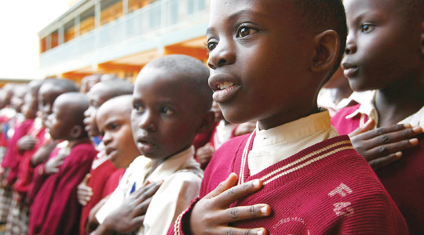
These Ugandan children are lucky to receive education... UN figures show 75 million children worldwide are denied the basic right of primary education. Photo: Darrin Zammit Lupi.
Ugandan children sing beautifully. I'm drawn towards the classrooms by the angelic sounding voices tempered with an unmistakably African rhythm. The songs are more than just a welcoming ritual - they're an everyday part of life, something quintessentially African.
The outside walls of Katoosa Primary School in Kyenjonjo in western Uganda are colourfully painted, an extension to the classrooms themselves as they're covered with maps and biology diagrams. The dimly lit rooms are packed with enthusiastic children, peering through the large windows with more than just idle curiosity.
There is no such thing as a typical Ugandan school -some are no more than open air classrooms under a tree in the middle of a field, the blackboard hanging from a low lying tree branch. The teachers have few or no teaching aids.
At Loro primary school, in Oyam in the north of the country, the classrooms are huts with corrugated iron roofs. Barefoot pupils sit on the dusty floor cross-legged for hours on end, deep in concentration as they try to follow lessons. The children tightly clutch their bundles of pencils as though they're their most precious possessions - maybe that's exactly why.
Many of the young pupils don't have a meal throughout a whole day at school because their parents can't afford the 5000 shillings (US$ 2) a term to pay for school meals. How must that hungry child feel, when he has nothing to eat and the student sitting in the grass next to him is gobbling down his food? How can that child be expected to learn and develop at school, listen to the teacher, when the only thing he can hear is his rumbling empty stomach?
Whilst primary education is supposed to be universal, many families can't afford to send their children to school, for the simple reason that they're expected to pay for the child's meals. The government is trying to eradicate the practice of schools charging for school meals, but much remains to be done in that area. There is also a chronic lack of teachers. Government policy only allows districts to employ a certain number of teachers, but given the rapid population growth, those numbers are nowhere near sufficient.
Some children are luckier and attend private school. The Kyamusansala primary school in Masaka in southern Uganda, run by nuns of the Sacred Heart, is one of the better schools in the region. The pupils, all girls, are boarders, many orphans who lost both parents to AIDS, and they're guaranteed to get their meals every day. Teaching standards are high, classrooms are well equipped, the pupils wear smart, meticulously cared-for uniforms, discipline is strict but fair, and by and large, things appear no different to a well-funded school in the West.
Reminders of the scourge of AIDS are never far away. A wooden signpost nailed to a tree near the main entrance reads "Be aware of HIV/AIDS". At the Katoosa Primary School in Kyenjonjo in western Uganda, a patch of grass in an otherwise dusty field is dotted with boulders with similar messages painted on them "AIDS kills," Together we can fight AIDS, AIDS Petients (sic) need care and support." With Uganda having been one of the worst affected countries, authorities are making sure that AIDS awareness campaigns target children by the earliest possible age.
According to UN figures, some 75 million children worldwide are denied the basic right of a primary school education. These children, left without the chance to learn, will grow up in poverty, with no hope, no ambition and no future. Uganda appears to be one of the success stories - in only five years, the country managed to double the number of children in primary schools to over 90 per cent.
Yet, the issue is not so clear cut. The Millennium Development Goals, which were agreed internationally to reduce poverty levels and improve education and health worldwide, were imposed on African countries as a condition for debt relief. The pressure this exerted on the education system has almost brought it to its knees, according to Madeleine Bunting writing in The Guardian. Classes of over 75 students are commonplace; there aren't enough books, blackboards, teaching materials. The priorities are access, equality and quality - in that order - putting the Ugandan authorities in a dilemma over whether to go for quantity or quality, which is no choice at all.
Some pupils at Kyamusansala school are intently watching me, but they shyly turn away when they realise I've noticed. They're interested in my cameras. We strike up a conversation of sorts, I show them some pictures, and ask them what they want to do when they grow up. One wants to be a doctor, another wants to join the Sisters of Sacred Heart. All the children have dreams, and given the chance, given the right education, many will achieve those ambitions, however lofty they may appear.
This is the fifth in a series of reports from Uganda raising awareness about the UN Millennium Development Goals with the cooperation of SOS Malta.

