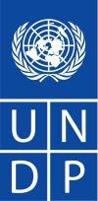

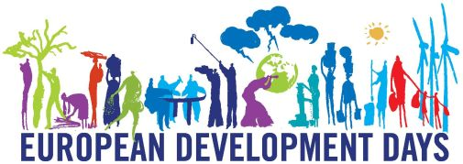
PRESS RELEASE

New EU states debate how to spend their 600m USD of aid

The total aid budget of the 12 new EU members
is expected to exceed 1.3bn USD by 2010

The new members of the European Union will contribute to discussion on development cooperation priorities in preparation for the European Development Days (7-9 November). The European Commission, the United Nations Development Programme (UNDP) and non-governmental organizations joined their efforts to raise public awareness in the new and emerging European donor countries by organizing parliamentary debates on development cooperation in each of the new member states.

Previously recipients of aid, now members of the donor community with funding and invaluable experience - twelve countries, which joined the European Union after
1 May 2004 committed to reduce global poverty and support poorer nations in pursuing the Millennium Development Goals. Their debates will be organized around 17 October - International Poverty Eradication Day. The events will gather decision-makers, members of parliaments, the international community and non-governmental organizations to discuss national, European and global development policies. The participants will primarily discuss their countries’ contribution and role in building global partnership for development.

Increase in the official development assistance numbers and improvement of its quality and effectiveness require public awareness about development cooperation, its reasons and benefits. Therefore the organizers of this initiative would like to trigger a public debate on objectives of development aid, its volume, quality, means of delivering and finally results. Governments, non-governmental organizations and international institutions are more and more active in this field and would like to address it also to national parliamentarians.

Established donors have been involving their societies and decision-makers in development for at least 30-40 years, however still 4 in 5 citizens of the European Union never heard about the Millennium Development Goals – according to the July 2007 survey by the European Commission. Raising the issue of development cooperation is particularly challenging in some of the newer member states of the EU as it is still a new topic for their nations.

The new EU members received significant support from other nations and now are in a position to help others. They are ranked in the UNDP Human Development Index amongst the 60 most developed countries in the world ranging from Slovenia (27) to Romania (60). Despite their internal developmental challenges, for over 100 other nations, where living conditions are harsh and unforgiving, these twelve countries are considered role models of transition.

In total, the 12 new EU members contributed to global development assistance with approximately 600 million USD last year. They have committed to increase significantly their official development assistance to 0.17 % of their gross national income by 2010, which combined should exceed 1.3 billion USD. This volume is enough to lift millions of people out of extreme poverty. The 22 richest countries spent 104 billion USD on development assistance in 2006 (OECD data), with more than half coming from the European Union.
The Millennium Development Goals (MDGs) are eight goals to be achieved by 2015 that respond to the world's main development challenges. The MDGs are drawn from the Millennium Declaration adopted by 189 nations in 2000.
More information: Jan Szczycinski, Communications Officer, UNDP Poland, jan.szczycinski@undp.org, tel. +48 22 576 81 89, mobile +48 609 458 216
http://europeandcis.undp.org/mdgdebates

